**IT24100237**

**Bandara R.M.G.L**

**PS Lab 05**

**1. Import the dataset (’Exercise – Lab 05.txt’) into R and store it in a data frame called ”Delivery Times”.**

**2. Draw a histogram for deliver times using nine class intervals where the lower limit is 20 and upper limit is 70. Use right open intervals.**

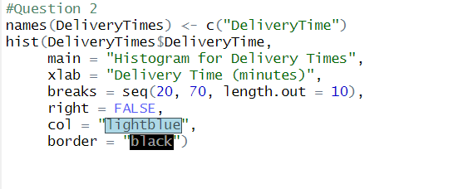

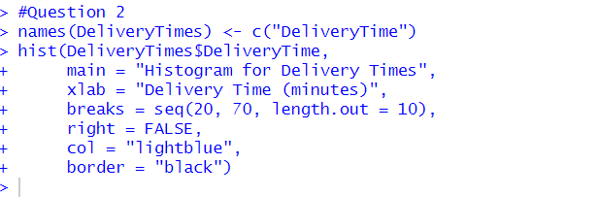

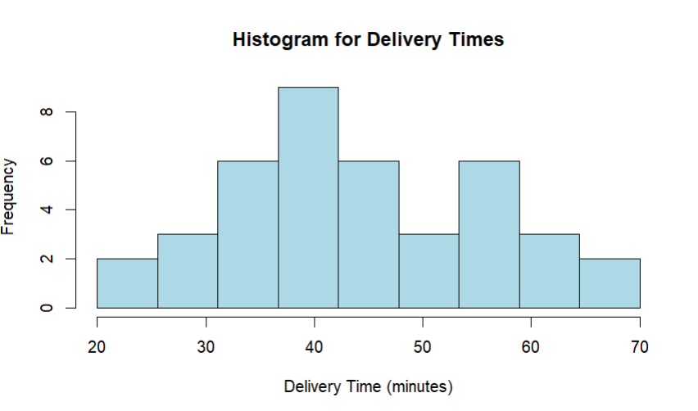

**3. Comment on the shape of the distribution.**

This distribution is approximately symmetric: Because left and ride sides centers are fairly balanced. Similar to normal distribution and not extreme outliers or long tails and also its perfectly smooth because of the small sample.

**4. Draw a cumulative frequency polygon (ogive) for the data in a separate plot.**

